WEB DEVELOPMENT
WED5112POE
Part 1: Website Project Proposals
Donald Mudzani
Student Number: ST10512213

Table of Contents
Proposal 1: Paw Haven Animal Rescue (Non-Profit Organisation) — SELECTED 3
1. Organisation Overview 3
2. Website Goals and Objectives 3
3. Current Website Analysis 3
4. Proposed Website Features and Functionality 4
5. Design and User Experience 4
6. Technical Requirements 10
7. Timeline and Milestones 10
8. Budget 10
9. References 10
Proposal 2: Kelder & Vine (Small Business — Boutique Wine & Deli) 11
1. Organisation Overview 11
2. Website Goals and Objectives 11
3. Current Website Analysis 11
4. Proposed Website Features and Functionality 11
5. Design and User Experience 12
6. Technical Requirements 17
7. Timeline and Milestones 17
8. Budget 17
9. References 17
3. Content Research and Sourcing — Paw Haven Animal Rescue 18
Sitemap: 19
GIT HUB LINK 19

Proposal 1: Paw Haven Animal Rescue (Non-Profit Organisation) — SELECTED

1. Organisation Overview
Name: Paw Haven Animal Rescue (fictional NPO)
Paw Haven is a fictional non-profit animal rescue proposed as the subject of this project. It is imagined as a small Johannesburg-based shelter that took in stray and abandoned dogs and cats, rehabilitating and rehoming them through community adoption drives.
Mission: To rescue, rehabilitate, and rehome abandoned and stray animals while promoting responsible pet ownership.
Vision: A community where every companion animal has a safe, permanent home.
Target Audience: Prospective adopters, individual donors, corporate sponsors, and volunteers, mainly aged 20-45, based in and around Johannesburg.

2. Website Goals and Objectives
- Increase visibility of adoptable animals to raise adoption rates.
- Grow one-off and recurring donations through a clear, trustworthy online presence.
- Recruit volunteers for shelter and event-based roles.
- Provide an easy way for the public to enquire before visiting or adopting.
Key Performance Indicators:
- Number of enquiry-form submissions per month.
- Number of volunteer sign-up enquiries per month.
- Time users spend browsing the adoptable-animals content.

3. Current Website Analysis
As a newly proposed organisation, Paw Haven has no existing website; there are no legacy strengths or weaknesses to analyse. This is treated as a greenfield build. The gap this fills is specific: smaller NPO shelters in the area typically rely only on a Facebook page, which cannot support a structured adoption enquiry with volunteer/sponsor options; a dedicated site directly addresses that limitation.

4. Proposed Website Features and Functionality
- Home page with a rotating highlight of recently rescued animals and a clear call to action.
- About page covering the organisation's story, mission, and team.
- Adopt page (site's Products/Services equivalent) listing animals available for adoption.
- Enquiry page with a form allowing visitors to enquire about adopting, volunteering, or sponsoring.
- Contact page with details for the main shelter and a second off-site adoption-event venue, satisfying the requirement for more than one mapped location.

5. Design and User Experience
Colour Scheme: Warm, approachable palette: soft terracotta and cream base tones with a deep forest-green accent, avoiding harsh or clinical colours.
Typography: A rounded, friendly sans-serif for headings paired with a highly legible sans-serif for body text, to keep the tone warm without sacrificing readability.
Layout and Design: Simple, single-column-led layout on desktop with generous imagery, shifting to a stacked layout on smaller screens in Part 2.
Navigation is kept to five clear items so a first-time visitor can find how to adopt, donate, or volunteer within two clicks. Forms are placed prominently rather than buried at the page bottom.
See wireframes below (layout and information hierarchy only; not final designs).

Home page
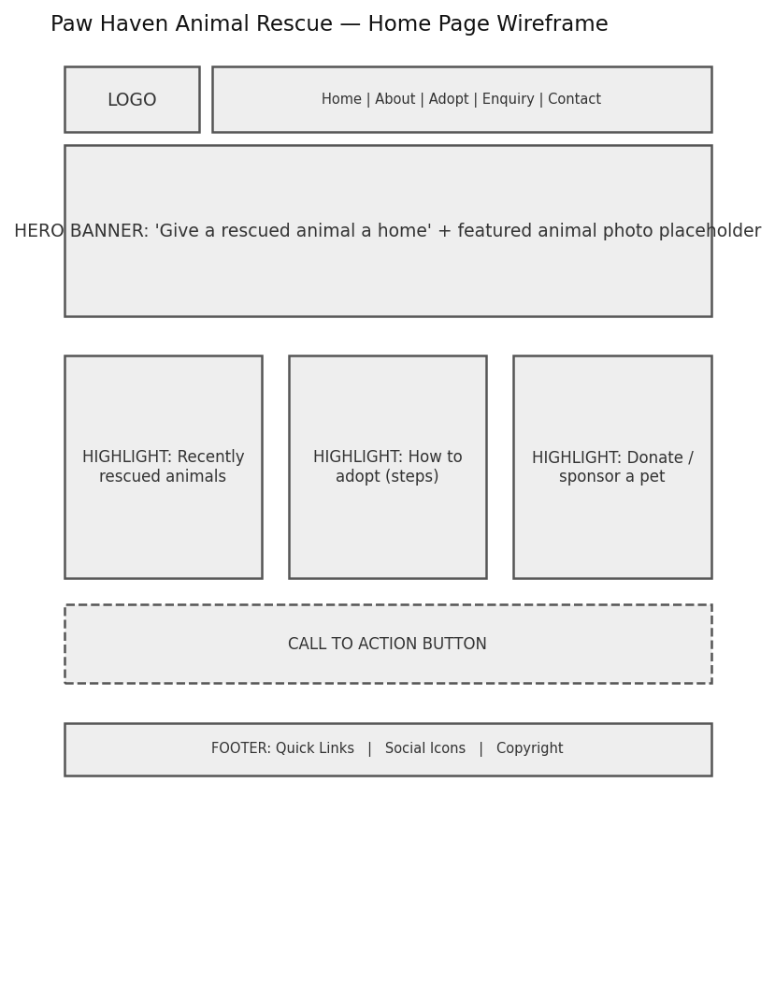
Figure 1: Home page wireframe — Paw Haven Animal Rescue. [Personal drawing].

About page
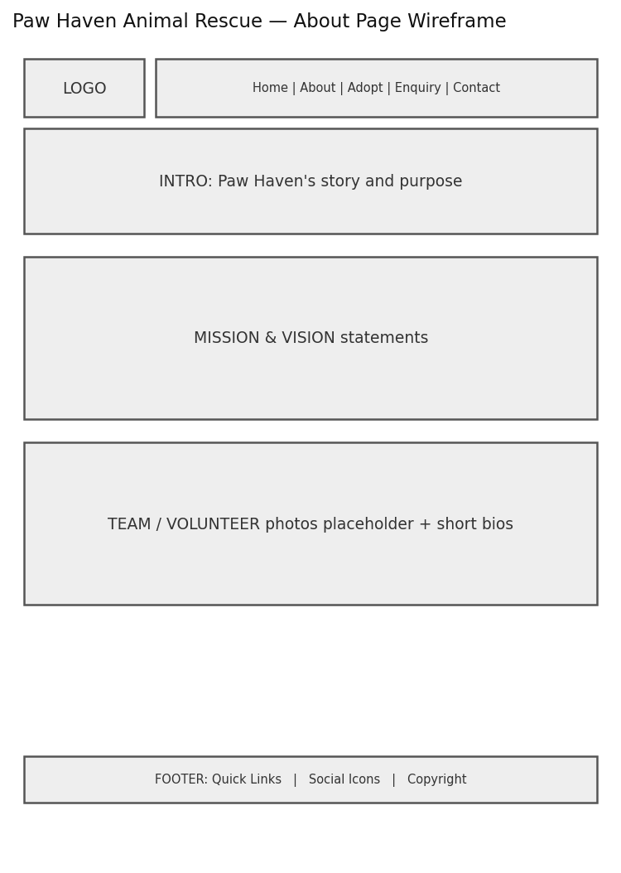
Figure 2: About page wireframe — Paw Haven Animal Rescue. [Personal drawing].

Adopt page
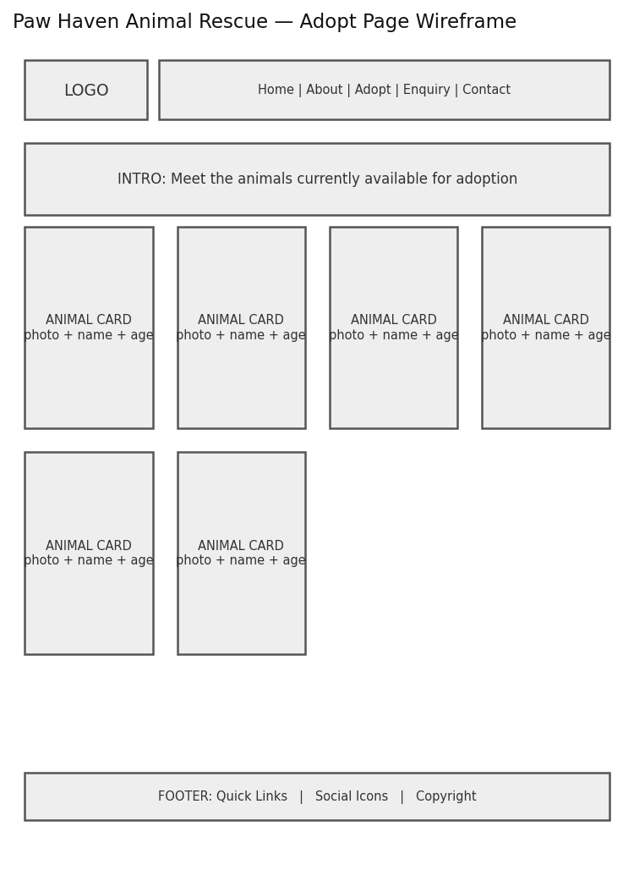
Figure 3: Adopt page wireframe — Paw Haven Animal Rescue. [Personal drawing].

Enquiry page
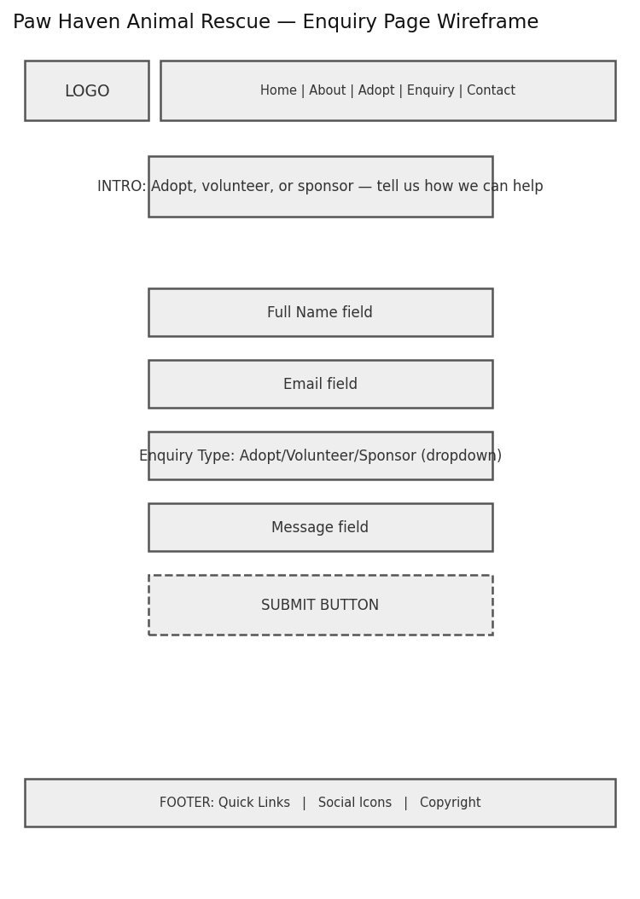
Figure 4: Enquiry page wireframe — Paw Haven Animal Rescue. [Personal drawing].

Contact page
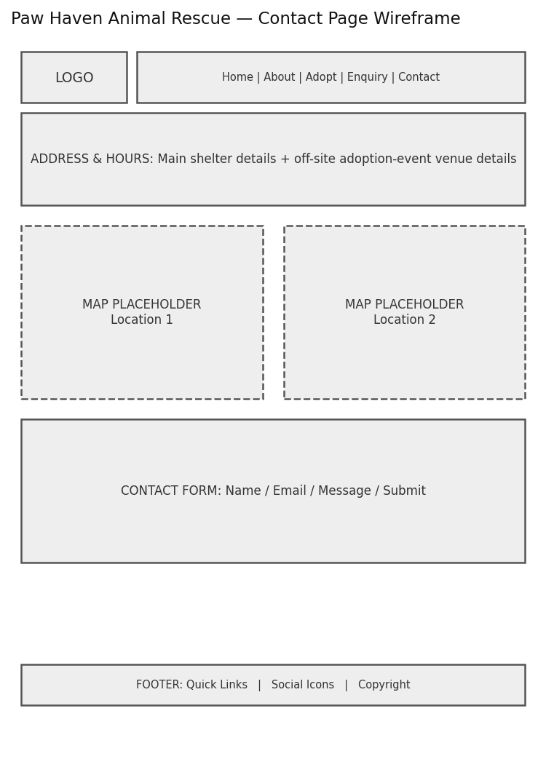
Figure 5: Contact page wireframe — Paw Haven Animal Rescue. [Personal drawing].

6. Technical Requirements
The website will be developed using HTML for the page structure, CSS for styling and JavaScript for functionality in later parts of the POE. Visual Studio Code will be used as the development environment, while Git and GitHub will be used to manage and track the project files. The website will be tested using a modern web browser to check that the pages and navigation work correctly. A free hosting platform may be used when the website is deployed.

7. Timeline and Milestones
- Week 1-2: Proposal approval, research, and content sourcing (Part 1).
- Week 3-4: Wireframes, sitemap, and HTML foundation (Part 1).
- Following submission: CSS styling and responsive design (Part 2).
- Following submission: JavaScript functionality, forms, and SEO (Part 3).

8. Budget
Based on real market rates. Domain registration R105/year (xneelo, 2026). Free-tier hosting via Netlify: R0. Stock/CC imagery: R0. Estimated notional total: under R150.

9. References
https://xneelo.co.za/domains/ [Accessed 11 August 2026]
Microsoft, 2026. Microsoft Word (created the wireframes) & https://www.drawio.com/

Proposal 2: Kelder & Vine (Small Business — Boutique Wine & Deli)

1. Organisation Overview
Name: Kelder & Vine (fictional small business)
Kelder & Vine is a fictional boutique wine-and-deli shop proposed for this project, imagined as a small owner-run store in Stellenbosch selling regional wines, artisanal cheeses, and cured meats to locals and tourists.
Mission: To make quality regional wine and deli produce accessible and approachable for everyday customers and visitors.
Vision: To be the neighbourhood's first stop for a well-chosen bottle and a proper cheese board.
Target Audience: Local food-and-wine enthusiasts, tourists visiting the Cape Winelands, and businesses seeking corporate gift hampers.

2. Website Goals and Objectives
- Showcase the product range online to drive in-store visits and gift-hamper enquiries.
- Provide clear information on tastings and events.
- Give tourists an easy way to find the store and enquire ahead of visiting.
Key Performance Indicators:
- Number of hamper/tasting enquiries submitted per month.
- Number of visits to the Products page.
- Repeat visits to the Contact/directions page.

3. Current Website Analysis
Kelder & Vine is proposed as a new business with no existing website; this project establishes its first web presence rather than redesigning an existing one. The gap this fills is specific: independent Stellenbosch wine-and-deli sellers without a site rely on passing foot traffic alone, missing tourists who plan visits online before arriving — a dedicated site captures that pre-visit search.

4. Proposed Website Features and Functionality
- Home page introducing the store with featured products.
- About page covering the owner's story and sourcing philosophy.
- Products page listing wine and deli categories.
- Enquiry page for gift-hamper and tasting-event requests.
- Contact page listing the main store and a second weekend market stall location.

5. Design and User Experience
Colour Scheme: Earthy palette of deep burgundy, warm cream, and charcoal, reflecting wine and artisanal produce.
Typography: A serif display font for headings to suggest craft and heritage, paired with a clean sans-serif for body text.
Layout and Design: Image-led layout with large product photography blocks, adapting to a simplified single-column layout for smaller screens in Part 2.
Clear navigation between browsing products and enquiring, with the enquiry form accessible from every page via the main menu.
See wireframes below (layout and information hierarchy only; not final designs).

Home page
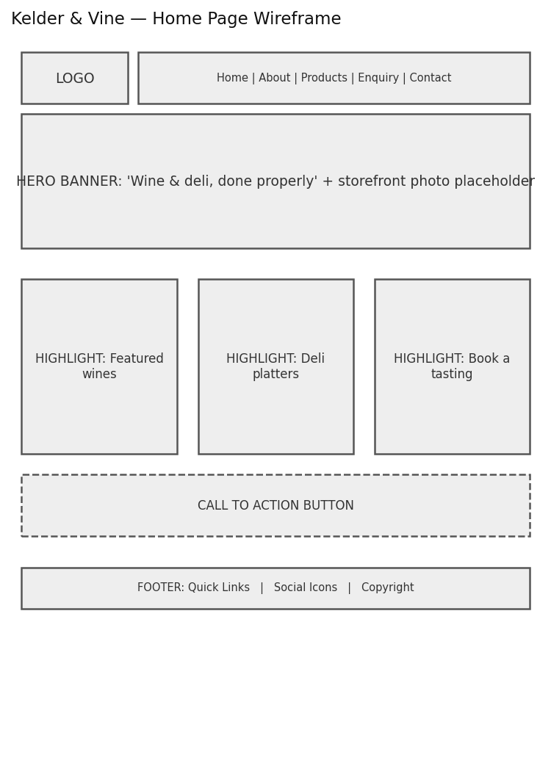
Figure 6: Home page wireframe — Kelder & Vine. [Personal drawing].

About page
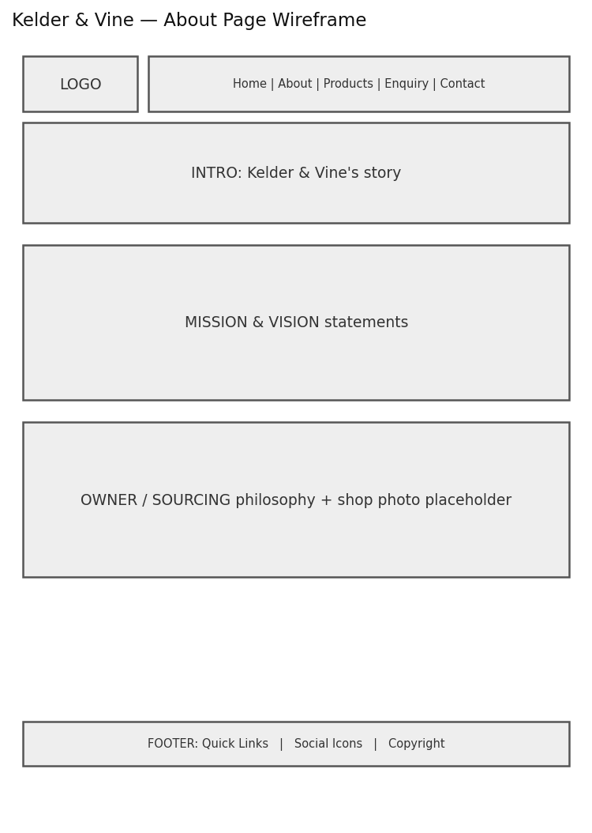
Figure 7: About page wireframe — Kelder & Vine. [Personal drawing].
Products page
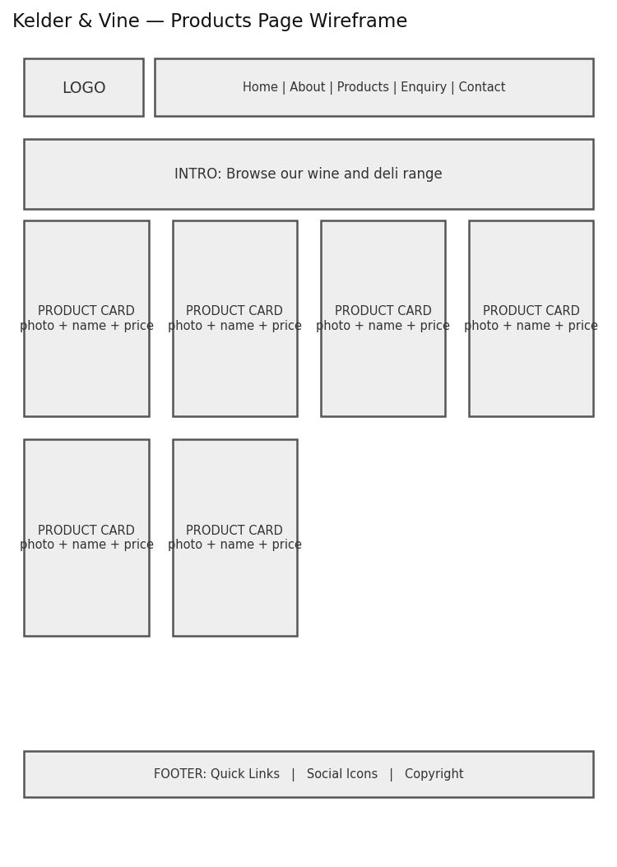
Figure 8: Products page wireframe — Kelder & Vine. [Personal drawing].

Enquiry page
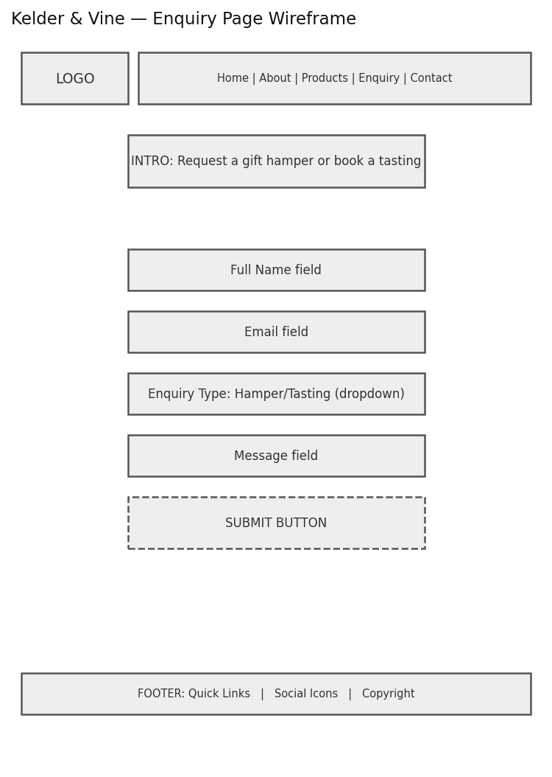
Figure 9: Enquiry page wireframe — Kelder & Vine. [Personal drawing].

Contact page
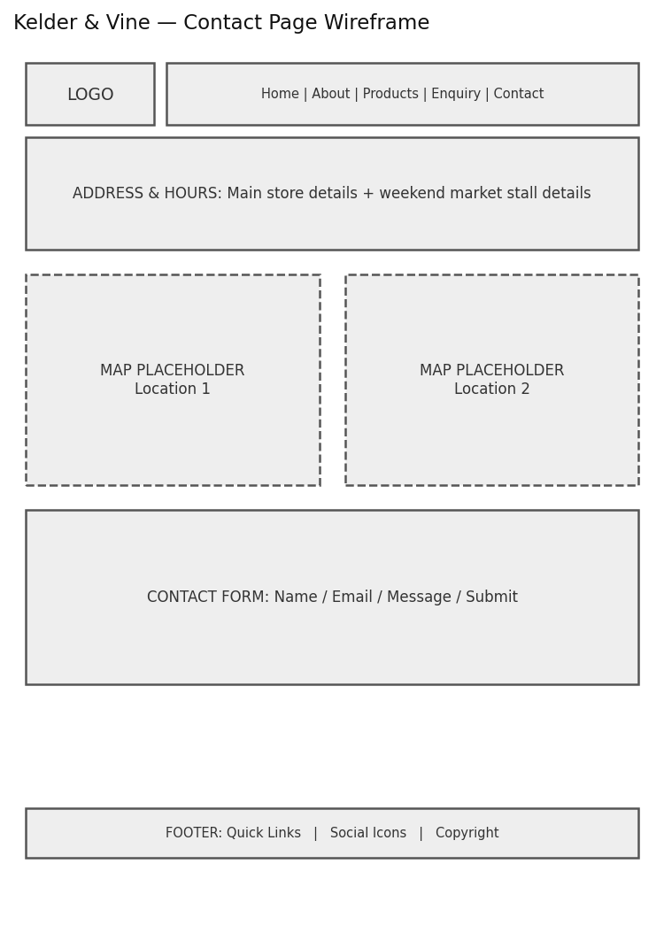
Figure 10: Contact page wireframe — Kelder & Vine. [Personal drawing].

6. Technical Requirements
Technical Requirements: The website will be developed using HTML for the page structure, CSS for styling and JavaScript for functionality in later parts of the POE. Visual Studio Code will be used as the development environment, while Git and GitHub will be used to manage and track the project files. The website will be tested using a modern web browser to check that the pages and navigation work correctly. A free hosting platform may be used when the website is deployed.

7. Timeline and Milestones
- Week 1-2: Proposal approval, research, and content sourcing (Part 1).
- Week 3-4: Wireframes, sitemap, and HTML foundation (Part 1).
- Following submission: CSS styling and responsive design (Part 2).
- Following submission: JavaScript functionality, forms, and SEO (Part 3).

8. Budget
based on real market rates. Domain registration (keldervine.co.za): R105/year (xneelo, 2026). Free-tier hosting: R0. CC-licensed imagery: R0. Estimated notional total: under R150.

9. References
https://xneelo.co.za/domains/ [Accessed 11 August 2026].
Microsoft, 2026. Microsoft Word (created the wireframes) & https://www.drawio.com/

3. Content Research and Sourcing — Paw Haven Animal Rescue
Per Section 3.1 of the brief, this document records where each page's content came from.
Home (index.html)
- All text is original content written for this fictional organisation. No citation required.
About (about.html)
- History, mission, vision, and team descriptions are original content, developed from the organisation profile established in the Website Project Proposal document.
- Team/shelter photo: AI-generated original illustration — see README References.
Adopt (adopt.html)
- All four animal profiles (Buddy, Whiskers, Nala, Max) are original fictional content created for this project. No real animals, real shelters, or real people are represented. See README References for final citations once chosen.
Enquiry (enquiry.html)
- Form field structure (adopt/volunteer/sponsor enquiry types) is derived directly from the brief's explicit requirement that an NPO's enquiry page must support volunteer and sponsor enquiries, not from an external source.
Contact (contact.html)
- Both addresses are fictional, created to satisfy the brief's requirement for more than one mapped location. They do not correspond to real premises.
- Map image: AI-generated illustration used as a structural placeholder — real map embeds are a Part 3 requirement
External sources used in Part 1
- xneelo (2026) — domain-registration pricing figure, cited in the Budget section of the Website Project Proposal and in README.md.
- W3Schools (n.d. — used as a learning reference for standard HTML formatting syntax, not as a source of copied content. Cited in README.md.
No external text, statistics, or claims have been used anywhere in the Part 1 content beyond what is listed above. Nothing has been copied from any website, textbook, or other student's work.

Sitemap:
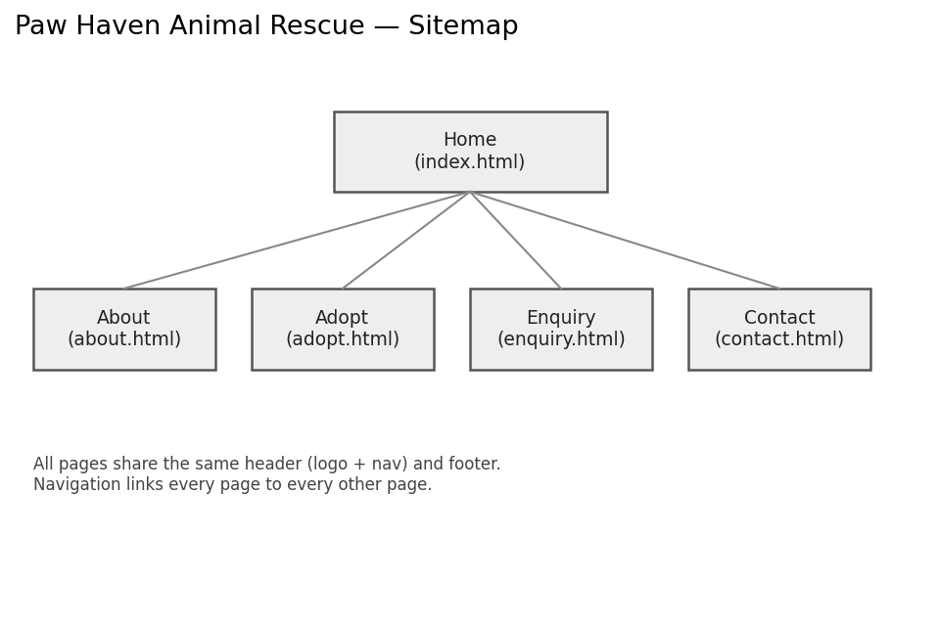 4-page hierarchy under a Home page, matching the file structure below. All pages link to all other pages via a shared navigation menu.

GIT HUB LINK
https://github.com/mudzani/ST10512213-WEDE51112-POE.git

